# Acronyms

CPC - Cost Per Click

DSBE - Demand and Supply Backend

MFE - Merch Frontend

TCNE - Total Clicks Not on eBay

* ATF = Above the Fold
* AVIP = Active View Item Page
* BBDB = Browse But Didn't Buy
* BM25 = Best Match 25
* BTF = Below the Fold
* CAL = Centralized Application Logging framework
* CBT = Cross Border Trade
  + Active CBT: When a buyer explicitly goes to a site that's not in his home country, and purchases a listing from a seller who is not in his home country.
  + Passive CBT: When a buyer buys on a site in his home country, but that site exposes listings from other countries, and the buyer buys from a listing that's not in the buyer's home country.
* CDAL = Common Data Access Layer
* CVIP = Closed View Item Page
* DS = Design Standard
* FISNG = Find Item Service (Next Generation)
* GMB = Gross Merchandise Volume Bought
* MIQ = Merchandise Image Quality
* PIQ = Predicted Item Quality
* PNR Error = either Page Not Responding (on page side) or Payment Not Received (on payment side)
* PW.MBE = Popular Items algorithm
* REC.RVI = Recently Viewed Items algorithm
* RIC.MBE = Related Items algorithm
* RPP = Retail Promotional Platform
* RTM = Real time messaging
* SIC.MBE = Similar Items algorithm
* SOI = Seller's Other Items
* SME = Seller Marketing Engine
* SMR = See More Recommendations (http://www.ebay.com/rcm/?itm=$SOME_ITEM_ID)
* SRP = Search Results Page
* RR = Right Rail (in placements)
* VI = View Item Page

DWRM

* A release management app for data integration projects in DW, support Ab Initio project for Batch ETL (e.g. DINT-CORE, DINT-ARCH ), Self-Service Onetime Release and Maven project for Streaming or Hadoop ETL (e.g. Tora, DBStreaming).
* <https://dwrm.dss.vip.ebay.com/>

Repo

Bandrui - seller reporting tool

Nori - merch API

Napkin - caching solution

# Altus

## Architecture

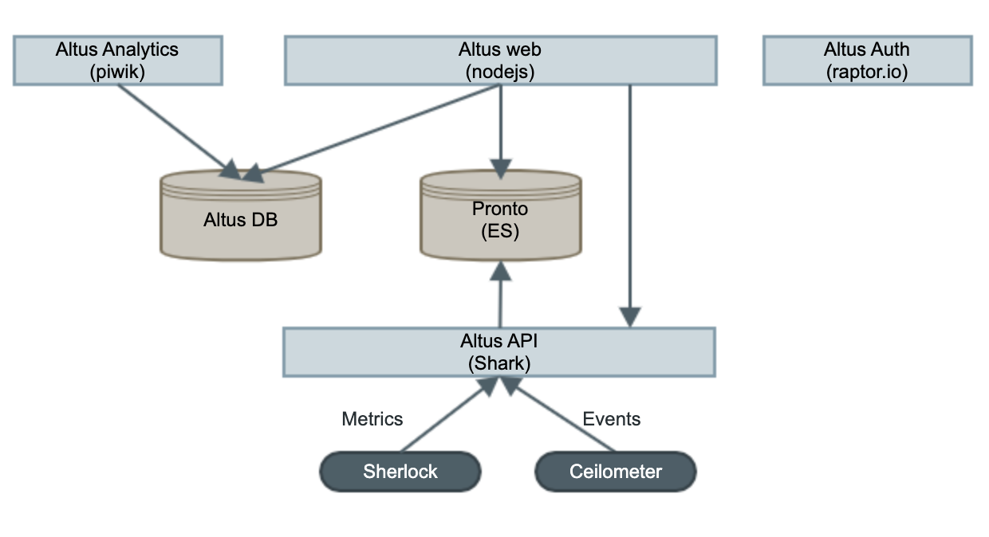

# Analytics University

## Analytics Intro

Data Consumer vs Data Producer

### Data

Transactional - Users, Bids, Listings, Transactions, Accounts (invoicing), Feedback, Email, Shipment, Customer support records

Behavioral - Visits, Visitors, Page Views (Impressions), Clicks, Traffic Source, Devices

Inferred - Output of Data Science Models, Segmentations and Scores

### Zeta - go/zeta go/zeta-guide

Managed by DSS team

Query hadoop cluster

Metadata

Schedule a query

### AI Powered

Selling - price guidance, 2 min listing flow

Ads - recommendation, promoted listings

Managed payments & risk - buyer scam, listing fraud, [prohibited, restricted, & counterfeit items]

### Nous (Product Domain Behavioral Data) - go/nous20 go/nous20training

Reporting platform

Behavioral data without writing SQL

You can query a URL

#### Traffic

Page View - per day

Bounce Rate - when visitor comes to the site and they don’t generate any events and they leave the site

Entry Rate - how long the page is the 1st page in someone’s session

Exit Rate - how long the page is the last page in someone’s session

Visits - session of a period of time

GUIDs (Global Unique Identifier) - who’s who and mapping with cookies

Registered Visitors - we know who you are. Logged in user. Cookies not cleared.

**Segment**

Demography - age, registered site, gender, country, registered, buyer segment, seller segment

System - OS, Browser, Screen Resolution, Device, Experience (browser/mWeb), App Version

Session - Bounced Session, Site, Language, Traffic Source (direct vs SEO vs paid traffic), Referral Path (what was the page that go the people to the session), Entry Page

#### Heatmap

Red - where they are clicking the most

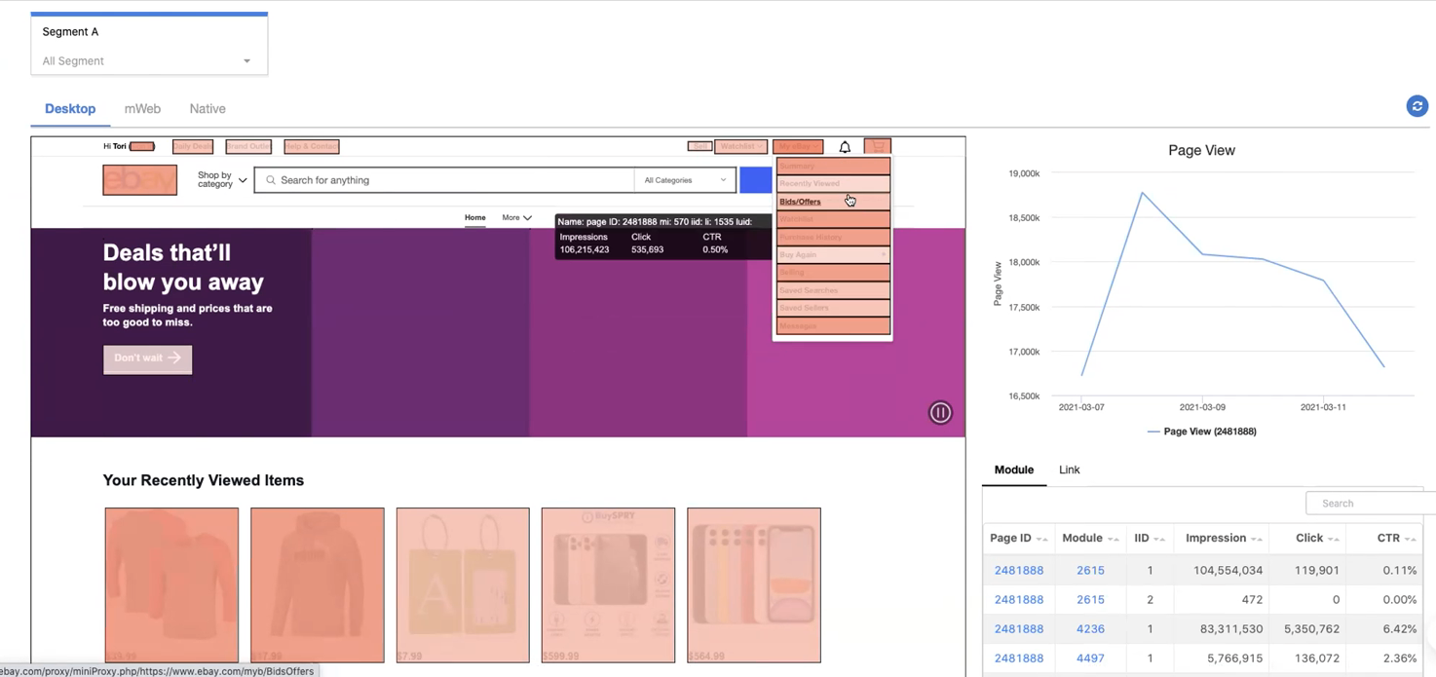

#### Path

Customer journey

First 20 pages of a session

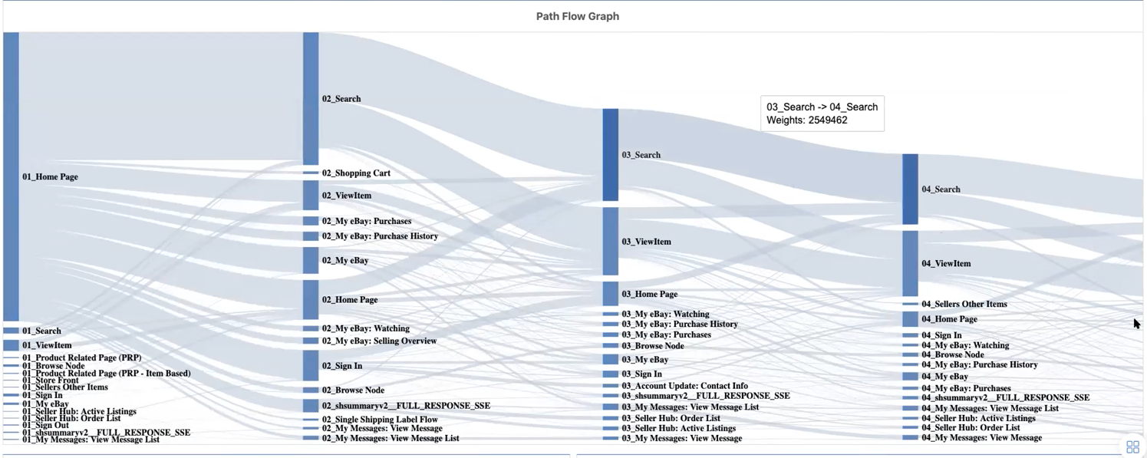

### References

<https://go/analytics-onboarding> (Getting Started with Analytics Data @ eBay)

<https://go/nous20> (Nous: Product Domain Behavioral Data)

<https://go/m1> (Marketing One: Marketing & Paid Search Data)

<https://gro.dss.vip.ebay.com> (Global Retail Optimization: Online Retail Life Cycle Data)

<https://go/experimentation> (Experimentation Services)

<https://go/tracking> (Tracking)

<https://go/qsx> (QuickStrike, Financial Information - requires additional access)

<http://go/zeta> (Data Discovery, Code Development)

<http://go/dss> DSS (Data Services & Solutions)

## Forming Business Questions

Why is the question important?  
Question components

Forming the question

Where are answers found?

What happened?

A line on the graph - goes up, or down, or stay flats

What did you do?

What might happen if we?

What is the size of the opportunity if we: add this thing, remove this thing, change this thing

What can we do?

Why is the question so important?

Well structured question:

* focus in on the data needed to answer
* avoid extracting irrelevant data and confusing the issue
* Narrow down the sources / tools that can help

What did you do?

* When?
* How long?
* Which site?
* Which platform?
* Which users?

# ATMOS

# BES (Business Event Streams)

[BES Presentations and Screencasts](https://wiki.vip.corp.ebay.com/display/messaging/BES+Presentations+and+Screencasts)

A business events related framework, with which users can produce or consume events.

Persistent events in Oracle

## High Level Architecture

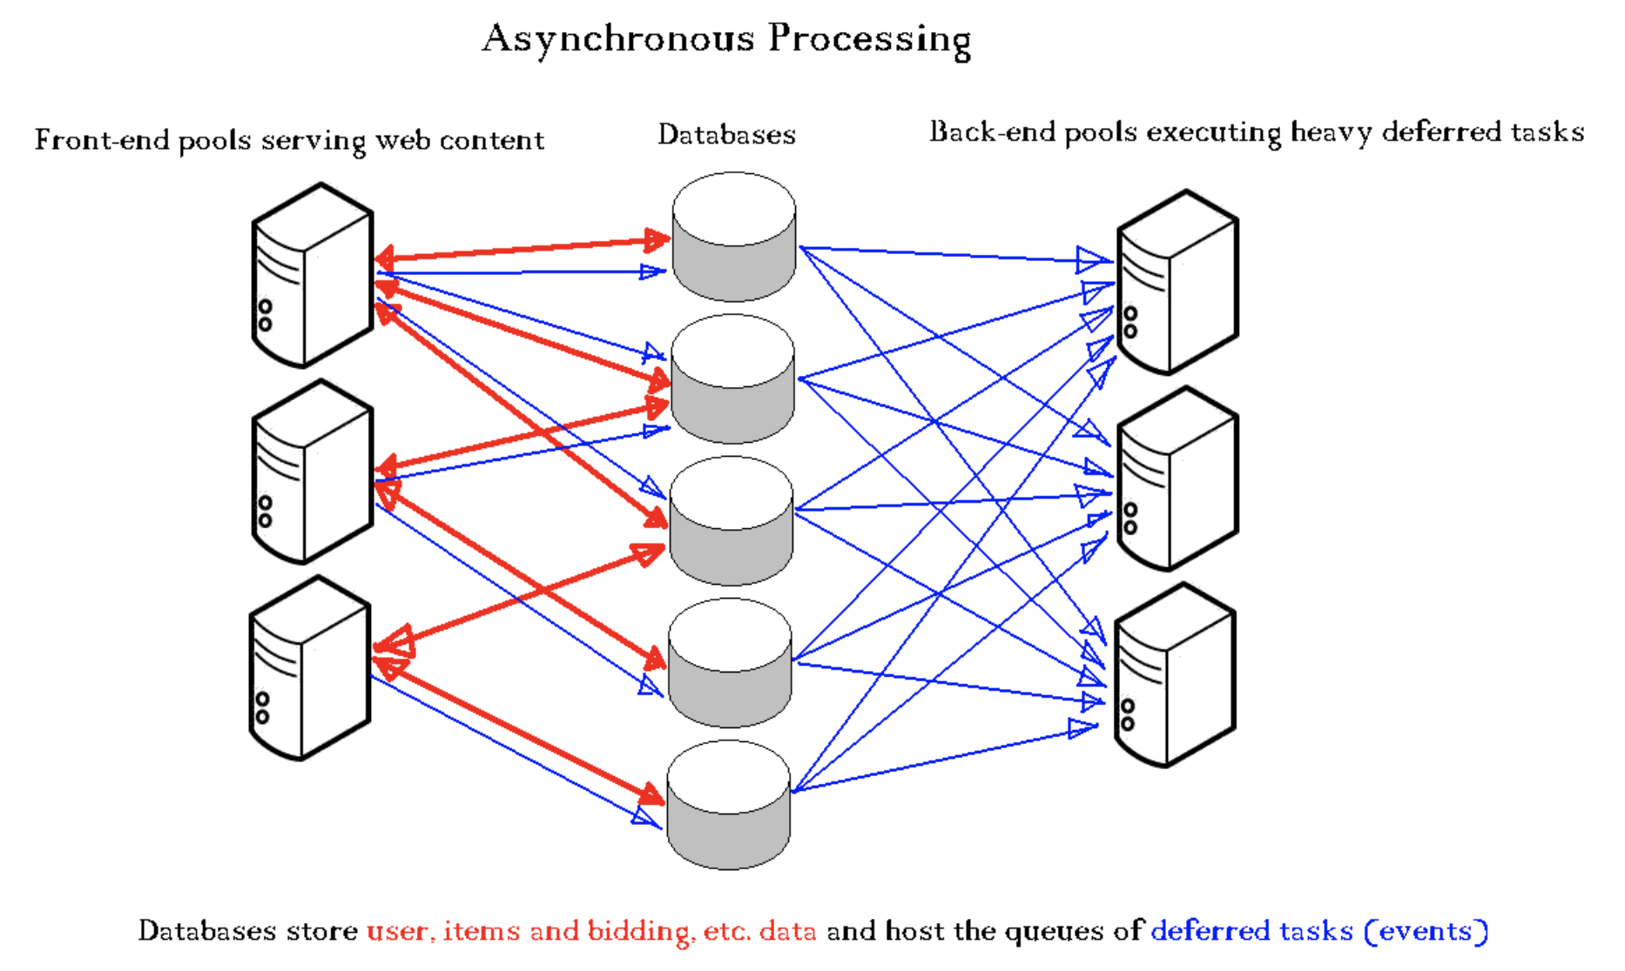

Asynchronous processing is the compromise between the needs to execute some heavy or lengthy computations and to keep the hardware cost down while not impacting user experience. It is achieved by deferring those computations and by executing them on dedicated hardware separate from the synchronous front-end processing flow.

Front-end servers place requests for those computations into queues from which the back-end servers retrieve them and then execute. Since the eBay environment is very database centric, the queues for those requests are implemented as database structures, which allows for choice of transactional or non-transactional requests, as well as for guaranteed delivery and virtually unlimited persistence of those requests.

BES infrastructure is an implementation of such architecture. It should be noted that since it is database based, the implementation of the consumer side is a set of threads each of which execute an infinite loop of polling the queues to discover any new requests, fetching those requests, dispatching the fetched requests to the business-logic-specific routine and marking those requests as processed after the routine completes.

### Producers

Publishing an event (or message, etc) is an operation of inserting a record into a database table. These tables are referred to as the "Event Tables". These event tables can actually be found on any logical host where BES events are produced.

In general, there are 5 types of BES Producers and they are listed below.

1. Transactional via PL/SQL

2. Non-Transactional via a separate DAL insert

3. Transactional via a Trigger

4. Transactional via a View

5. Time-based producer

Type # 1 is the recommended approach for most producers. PL/SQL is used to perform 2 modifications in one transaction. The first modification is performed on the business table which is the table that the application uses already. For example, for the ITEM.NEW event type, the business table is the EBAY_ITEMS table. The PL/SQL block would perform an insert to the EBAY_ITEMS table and an insert into the BES Event table in one transaction. This ensures that no BES events are ever lost. The modification to the business table could be an insert, an update, or a delete. In some cases, the modification to the business table results in 2 separate BES events to be created in one transaction. Support for the creation of 3 or more BES events in one transaction is currently not supported. Any DAL code that directly or indirectly extends BaseBesPlSqlProducer can serve as an example of publishing events this way.

Type # 2 can be used if a transaction is not required. Instead of using PL/SQL, the publisher of the event uses a separate DAL insert. The modification to the business table is performed in a separate transaction to the creation of the BES event. If the publisher dies before the BES Event is inserted, then the BES event is lost. Look at the BusinessEventUtil class and the code that calls its methods to see an example of this type of producer.

Type # 3 (Trigger) is generally frowned upon and requires special approval from the DBA's. No new BES triggers have been approved since approximately 2004.

Type # 4 (Views) can be used if the underlying business table has columns that can be mapped to columns in the BES event table. Such a view morphs a business table into an event table. As long as the underlying business table has a column or set of columns that when queried through a view form a monotonously growing sequence of unique positive numbers, those numbers can be used as event ids, which is required for BES to work. This type of producer only works to capture inserts. Updates or deletes cannot be used. Views are not recommended now since they result in coupling the business table and the BES Event Tables. This coupling makes any kind of migration much harder to accomplish.

Type # 5 is used for any time-based events. At the time of publishing, the producer specifies the delay which has to elapse before the event becomes available for delivery to any consumers subscribed to the event stream. An example of a time-based event is CPS.CLAIM.TIMEOUT.

### Consumers

Consumers must register themselves with the BES Framework and indicate the event types they are interested in. For each event type, the Consumer must create an EventProcessor and register the EventProcessor with BES. The EventProcessor is simply a callback. BES will poll for new events of a subscribed event type and call the Consumer's EventProcessor.processEvents() method with that batch of events. The EventProcessor must then iterate through the batch of events and perform whatever business logic is needed to process the events. For each event, the EventProcessor must provide a processing status. There are 3 possible statuses:

1. Successfully processed

2. Retry at a later time

3. Abandon the event

Most of the time, the event should be successfully processed. The EventProcessor indicates success by calling BusinessEventBatchSession.setSuccess(BusinessEvent event).

If the consumer is not able to process the event for some reason (e.g. some downstream dependency is not responding), but would like to try again in the future, then the EventProcessor should indicate the event should be retried at a later time. This is accomplished by calling BusinessEventBatchSession.setRetryInfo(BusinessEvent event, long retryIn, String reasonDescription). The retryIn parameter indicates how many seconds in the future to wait before retrying the event. This is the earliest redelivery time. The exact redelivery time will depend on many factors including the retry backlog and the consumer's polling interval for this event type. The reasonDescription parameter is a string which the EventProcessor can use to store any state information. The next time the event is re-delivered, this reasonDescription will be provided. There are cases when the BES framework will retry the event on behalf of the consumer. In this case, the BES framework may store its own reasonDescription in this field.

### Limitations

* Order is not guaranteed
* Once and only once delivery is not guaranteed. Consumers must be idempotent.
* SLA is not guaranteed. BES makes best effort to deliver events within SLA.
* No real-time delivery of events (<1 second)
* No events filtering. All events are delivered to a consumer.
* Payload size is limited to 16K

# BullsEye

Resources:

[Contextualization](https://docs.google.com/document/d/1NRQfzJm5ltNxHrbQcGcg0f5KOz4xael8ScOdTSP758c/edit#)

[Personalization 101 - Analytics University 2021](https://docs.google.com/presentation/d/1Euvn85ef94IiEnG4wpwQpPH8feB3Lr5PxrllfL6IB2s/edit#slide=id.g4c0e085fb6_0_0)

BullsEye is eBay’s Platform for Personalization. It has lot of data about the user accessible through a runtime engine. The different kinds of data are:

1. User Profile Data: This include information about age, sex, gender, demographics.
2. Historical purchases including BBOWA.
3. Summarized data about user like average purchases under different categories.
4. Real time user behaviour data including searches, clicks.

Bullseye is a best-in-class platform and service delivering real-time multi-dimensional customer insights that enable in-session customer targeting and personalization of their online experience.

It listens in realtime to customer behavioral and transactional activity, extrapolates the goodness and enhances it with the offline data assets via multi-dimensional algorithmic affinity/ propensity modeling.

Bullseye offers a hosting platform for predictive online model computation. Teams can develop and host their models in python and leverage its high volumes of customer data and platform features.

**Use cases**

Merchandising - Recently viewed/watched items, Personalized Deals

Buyer Growth - Better targeting of Coupons, Guest RVI

Display Advertising Platform - Ads targeting

Search - Contextual search, Autocomplete

RTM - personalized emails

Global Header - Cart count

B2C Selling - Is seller B2C/C2C

...

Assets in Bullseye

User Profile

* Demographics
* User DNA
* Seller Segmentation
* Aspect Graph
* Loyalty/Coupon Data
* AdChoice

Activity Timeline

* Last Viewed Item
* Recent Searches
* Last Transaction
* Bids
* Best offer
* Feedback
* Watchlist
* Shopping Cart (persite)
* INR

**Ecosystem with BullsEye**

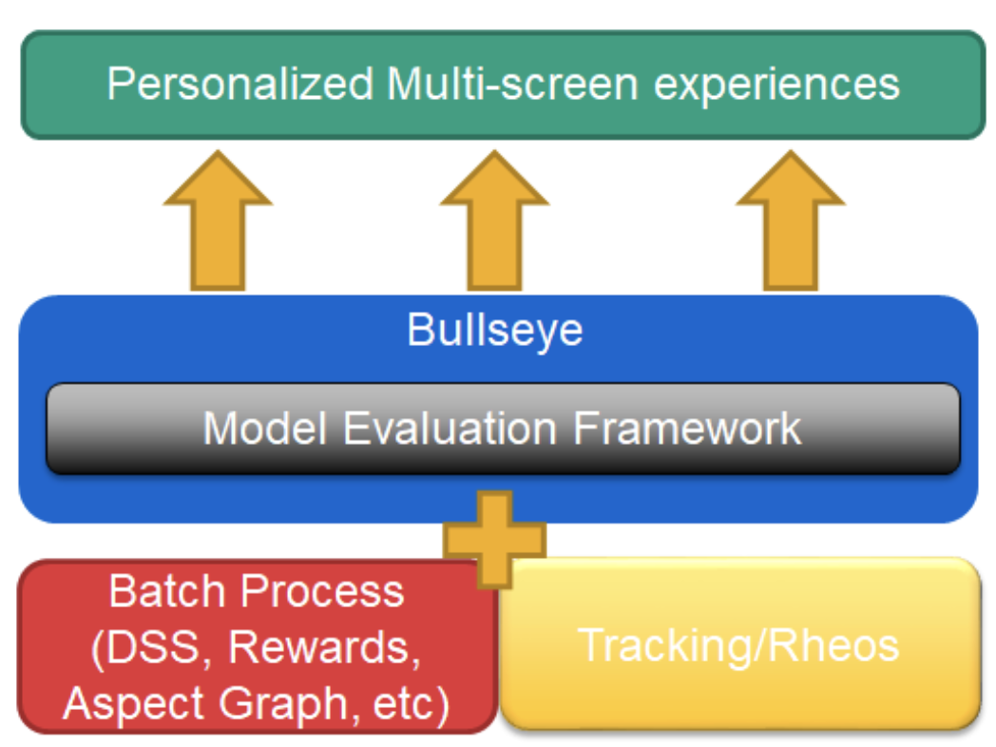

**Architecture**

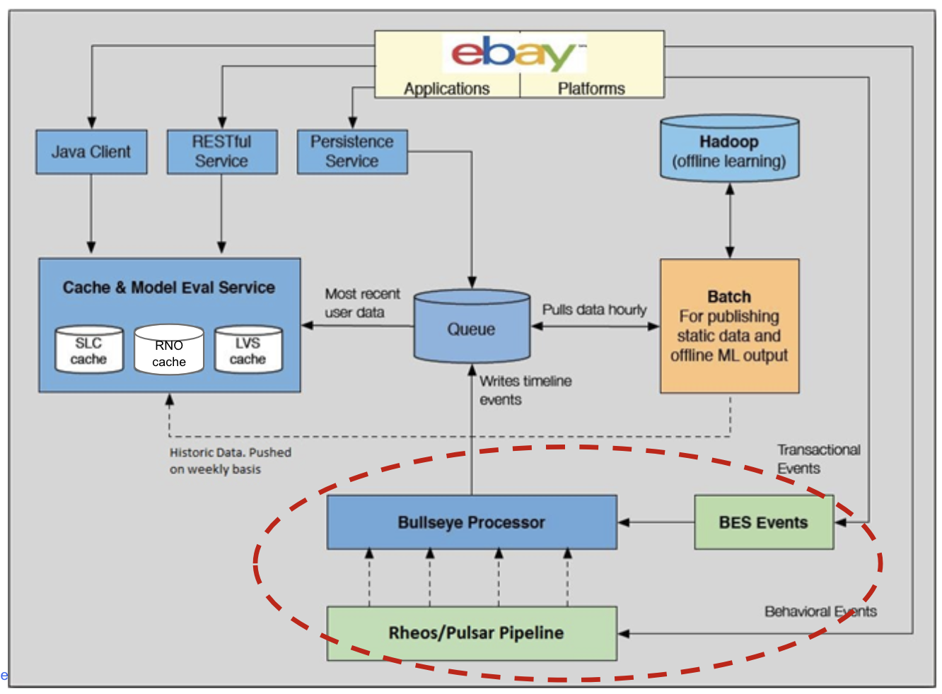

# Block Below Standard Seller from PL

## Architecture

### Seller Level Service

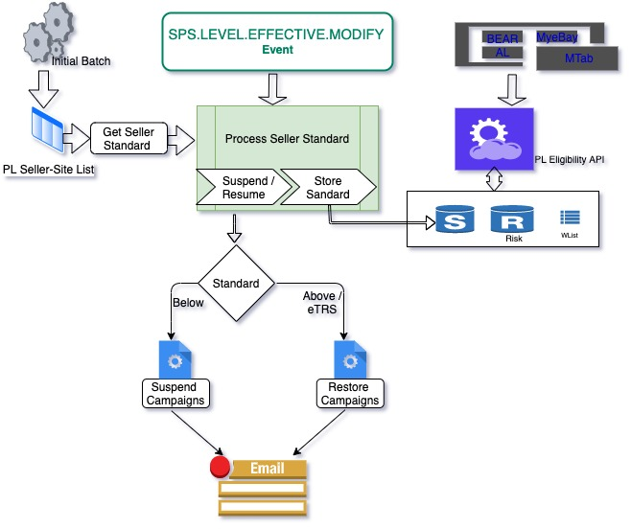

### Campaign State Transition Diagram

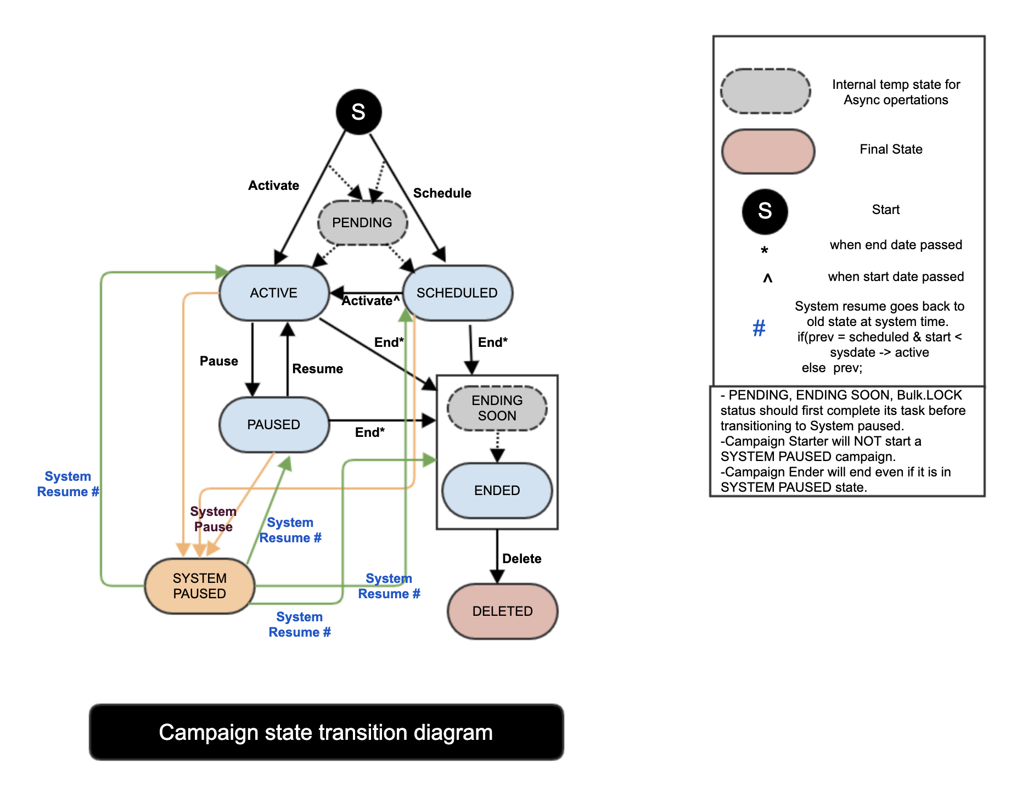

# Celery - Distributed Task Queue

## What is Task Queue

Task queues are used as a mechanism to distribute work across threads or machines.

A task queue's input is a unit of work called a task. Dedicated worker processes constantly monitor task queues for new work to perform.

Celery communicates via messages, usually using a broker to mediate between clients and workers. To initiate a task the client adds a message to the queue, the broker then delivers that message to a worker.

A Celery system can consist of multiple workers and brokers, giving way to high availability and horizontal scaling.

Celery is written in Python, but the protocol can be implemented in any language. In addition to Python there's node-celery and node-celery-ts for Node.js, and a PHP client.

Language interoperability can also be achieved exposing an HTTP endpoint and having a task that requests it (webhooks).

# Control Center

## Architecture

### Monitoring System

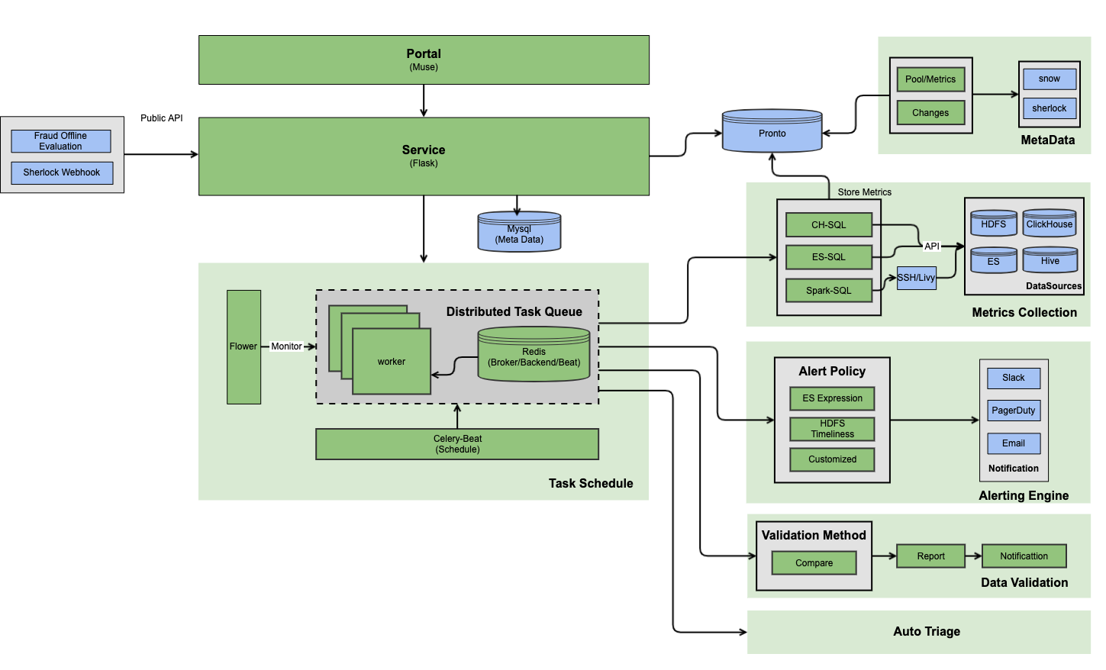

### Shepherd

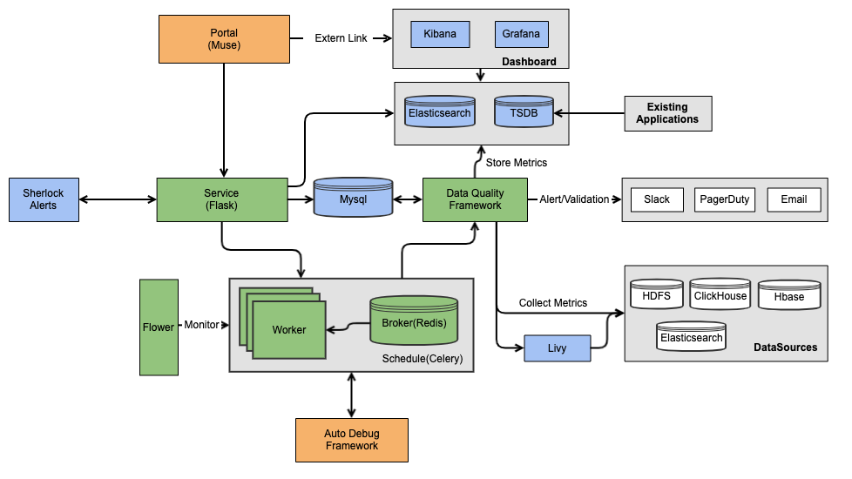

### Alert Rule Management

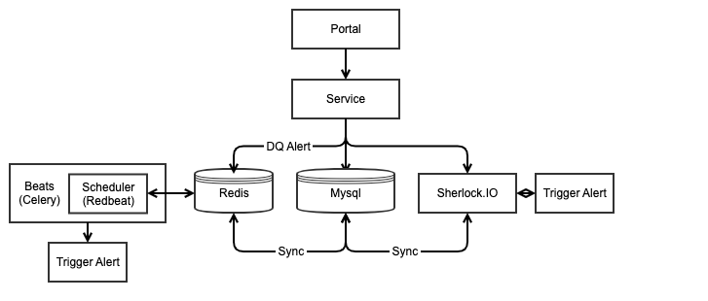

### Unified Alert Board

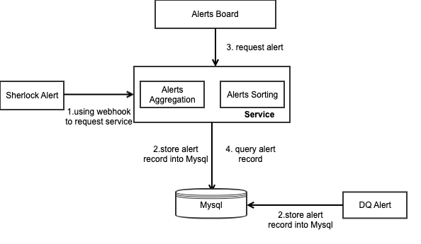

### Auto Debug

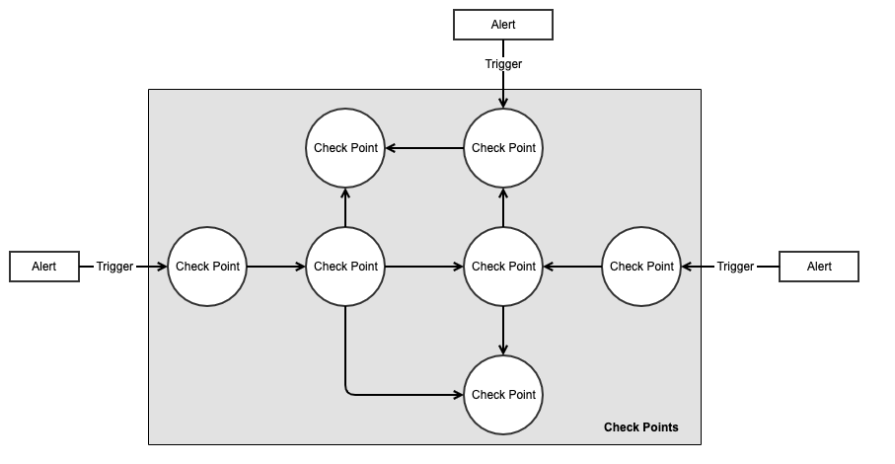

### Monitoring System Architecture

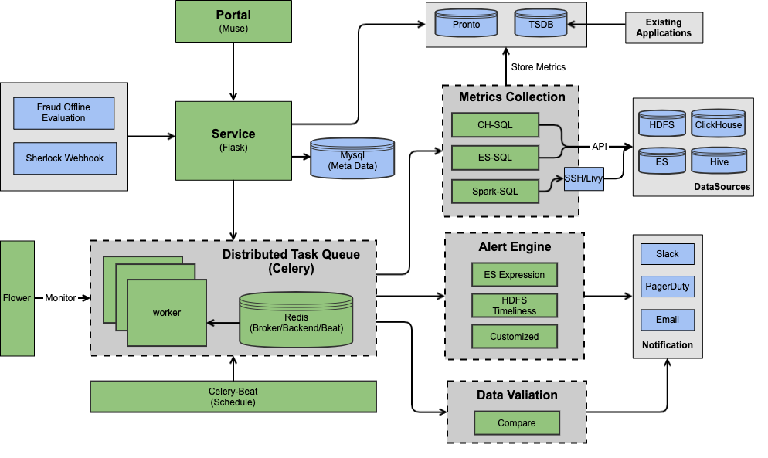

## Features

### Core Metrics

### Metadata

#### Pool Metrics

#### Changes

### Diagnosis

#### Auto Triage

## 

## Repositories

### Adssrejob

### Shepherd UI

### Shepherd API

# ClickCube

Sample

[2388028](https://clickcubeapp.muse.vip.ebay.com/explore?start=1642482000&end=1642741200&chart=line&options=%7B%22source%22:%22impressions%22,%22timezone%22:%22America/New_York%22,%22granularity%22:%22hour%22,%22dimensions%22:%5B%22placementId%22%5D,%22measures%22:%5B%22count%22%5D,%22filters%22:%5B%7B%22title%22:%22pageId%22,%22operator%22:%22equal%22,%22values%22:%5B%222388028%22%5D%7D,%7B%22title%22:%22placementId%22,%22operator%22:%22in%22,%22values%22:%5B%22101222%22,%22101220%22,%22101219%22%5D%7D%5D%7D)

# Cypress

<https://www.cypress.io/>

<https://github.com/cypress-io/cypress>

<https://wiki.vip.corp.ebay.com/display/PROMOTEDLISTINGS/CypressIO+-+Docs>

CypressIO is a modern web framework which is gaining popularity across the UI Testing space. It is a **user-friendly test automation tool for end to end testing, UI testing, regression suites, and integration and unit testing.**

Cypress is a popular front end testing tool built for the modern web. Its fundamentally and architecturally different than selenium.

# Elasticsearch

# Experiment

## Touchstone

Key Benefits

Touchstone de-couples business data preparation from EP core processing. Design a metadata-driven open system in which all users can on-board their own source data to participate in the EP core processing via self-services.

Meanwhile, Touchstone leverages Hadoop processing as source of Truth and deprecates TD processing. Rewrite the core processing jobs in Hadoop as more efficient map reduce jobs. Rolling processing is introduced to generate hourly results, plus joining with spark SQL, Touchstone can provide a lower SLA.

### Core Processing Flow

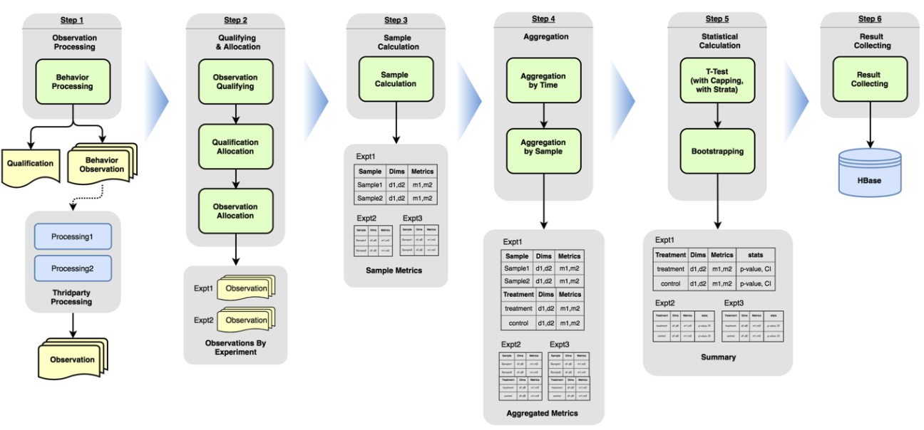

### Data Flow

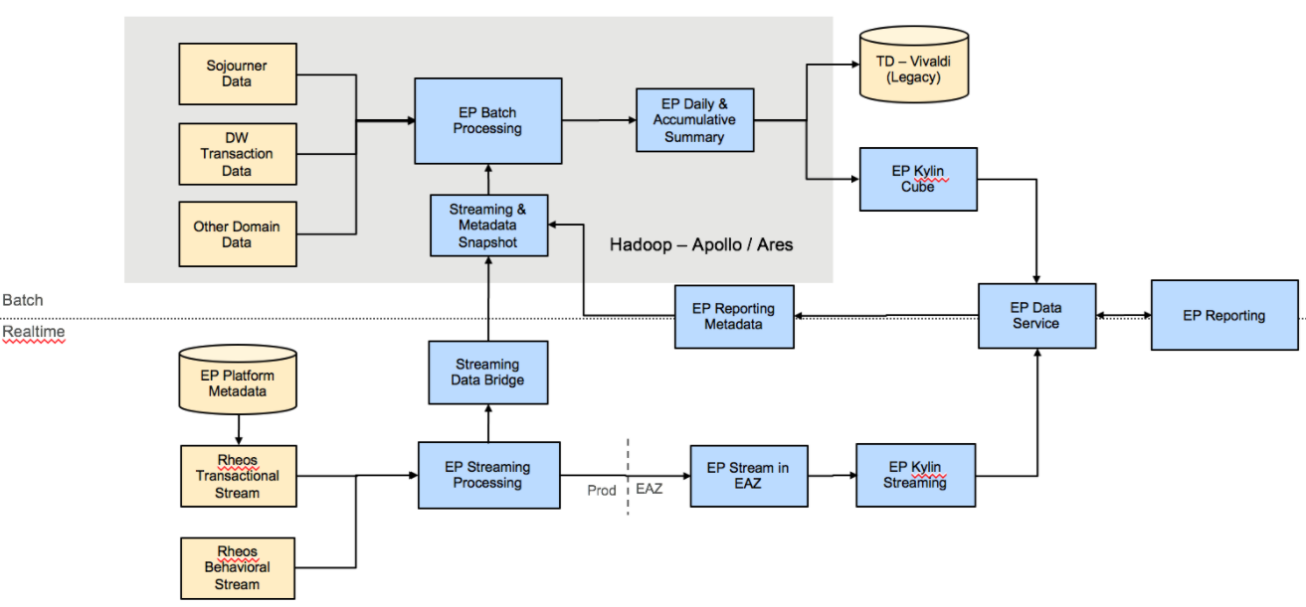

### Tech Stack

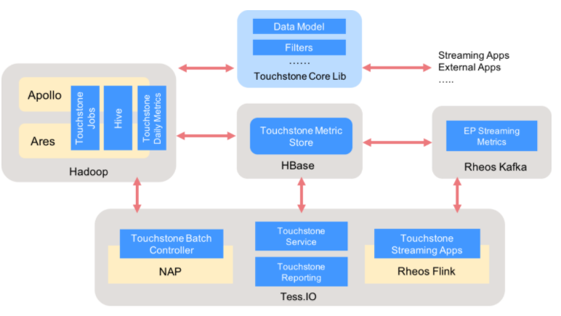

# Future (Publisher Network)

[Docs](https://docs.google.com/document/d/1Pil4V8xj0dO2tXn42Xw-yLufTw0V8Pjr5vuP7lGfuWA/edit#heading=h.effeyetmmkr)

# Grafana

[Getting Started](https://grafana.com/tutorials/grafana-fundamentals/#introduction)

# Ginger Client

# Home Page (HP)

# Homesplice

[Homesplice onboarding](https://github.corp.ebay.com/nume/mfe/wiki)

# Interview

## Recent College Grad

Who would you rather train? Let’s say for the whole day.

# Keystone

# MADSNAP

# MFE (Merchandise Frontend)

[MFE Onboarding](https://docs.google.com/document/d/13GALxamU42GahydWcF91_w0DZ6VTUW15QHcBBmCP8Bc/edit#heading=h.wwko5nj2yq4g)

[MFE Wiki](https://github.corp.ebay.com/nume/mfe/wiki)

## Architecture

### High-level Architecture

### 

### Sequence Diagram

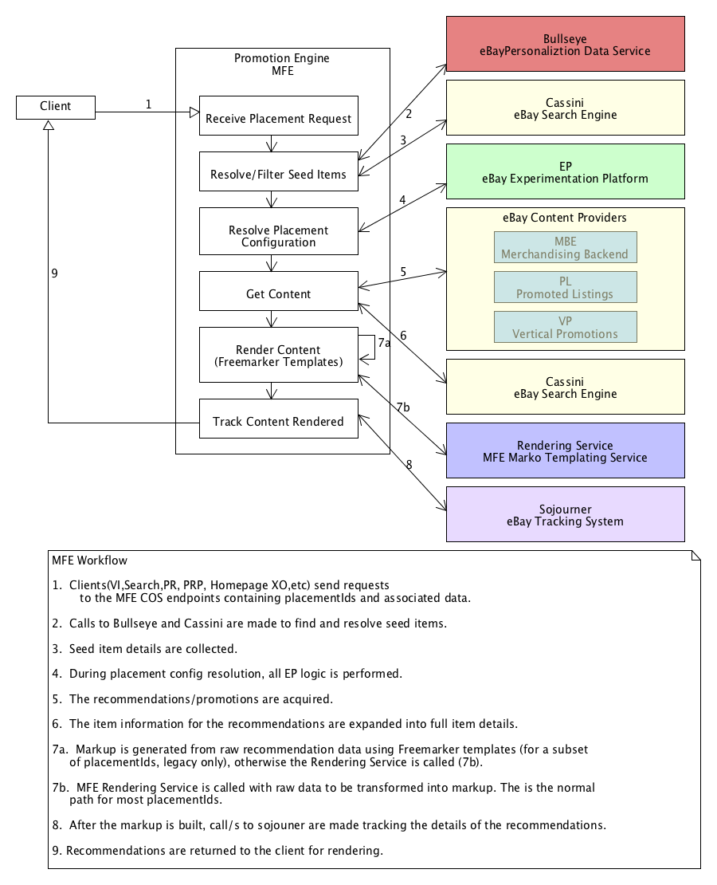

## MFE App Release Timeline

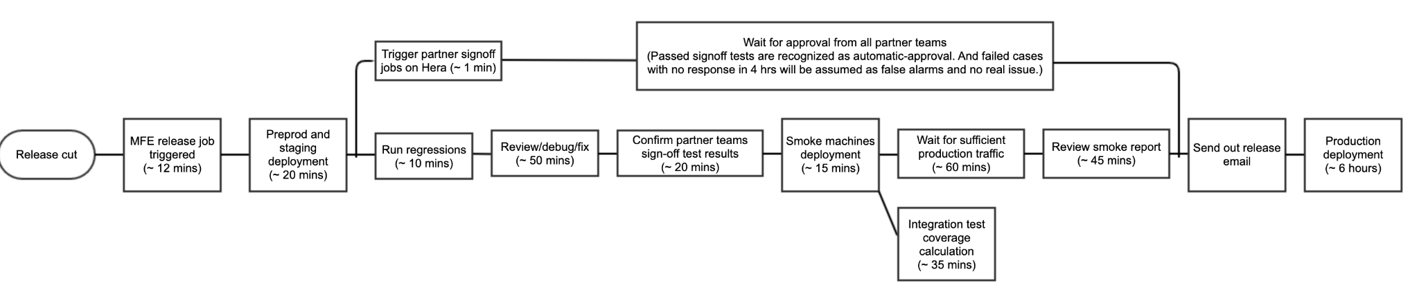

# Montage

# Nous

# Onboarding

## Merchandising - buyer’s personal shopper & seller’s best promoter

Recommendations on ebay website

Placements - horizontal recommendation of items

* Multiple placements per page
* Powered by different algos

View Item Page (the page)

Seed listings - what the page is all above

### Item recommendations

Sponsored items are substitutes

Above the fold

The fold - info of seed item

Below the fold

* More recommendations (sponsored items)
  + Recent views
  + Card layout - help buyer pivot
    - Type
    - Brand
    - Related of sponsored items

Sponsored - sponsored recommendations

* Ranking is impacted by ad rate (what the seller pays for ads)

Organic - (not sponsored)

* No impact from ad rate
* Purely relevance

The strips (placements) are selected and ordered by Page Optimization ML model

When buyers click on a merch recommendation and purchase the item within a certain time window. It then gets attributed to merchandising recommendation.

If a buyer searched for an item, then purchased an item, then it gets attributed to search.

Usually, a buyer clicks 1 recommendation in 1 month before purchase.

160+ placements across dweb, apps, mweb

23+ placements in email and notifs

8 sites supported

### Problem: given seed item, recommend most “relevant” items from ebay’s current inventory, within 200 msec. “Relevant” depends on the buyer's context.

Strategy used: “recall” and “ranking”

* Recall sets: title keyword similarity co-views (items viewed in the same user session), co-searches, sellers other items
  + Example:
    - Same-category co-views
    - Cross-category co-views
* Next, we rank these recall sets in a carousel.

### Problem: rank related items to find the best ones to show the buyer

Two types of impressions (users)

* Not clicked vs purchased (Ranking reco as binary classification)

Predict which one would convert (bought), which one wouldn’t.

Sort items by score, then top 12 show in desktop.

Title similarity, aspect similarity

Buyer history can determine optimal ranking

Gender is not a feature

Every buyer would have different ranking with same seed item

### Simplified System Flow

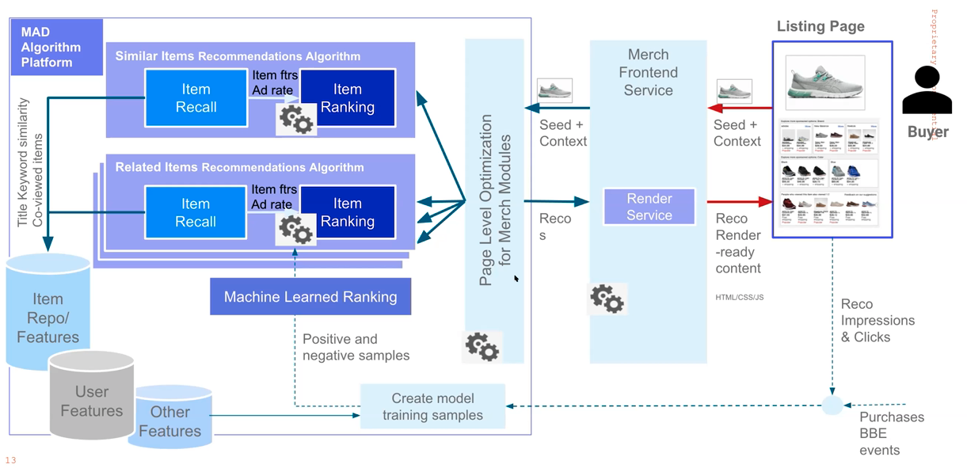

Page Level Opt decides which module to call. Each module has a different recall strategy (algorithm).

When buyer interacts (impressions) and clicks on certain items in the strips, these are collected with purchased data. I.e. purchased after 3 days are joined with impressions and click events and fed to the training model. And non-purchased goes to negative training samples. Training samples used for training the ranking.

How do we make money?

Ad rate can be used to re-rank (second round ranking) to give ebay’s highest expected revenue. Also, makes sure that the ranking is still relevant.

Page Optimization: Extreme Personalization

Library of 50+ algorithms and variants

High quality items repeated intelligently

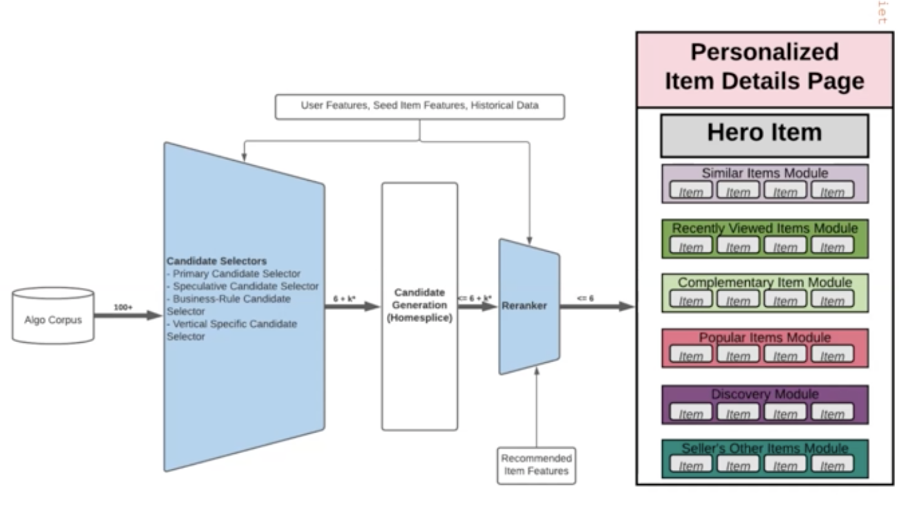

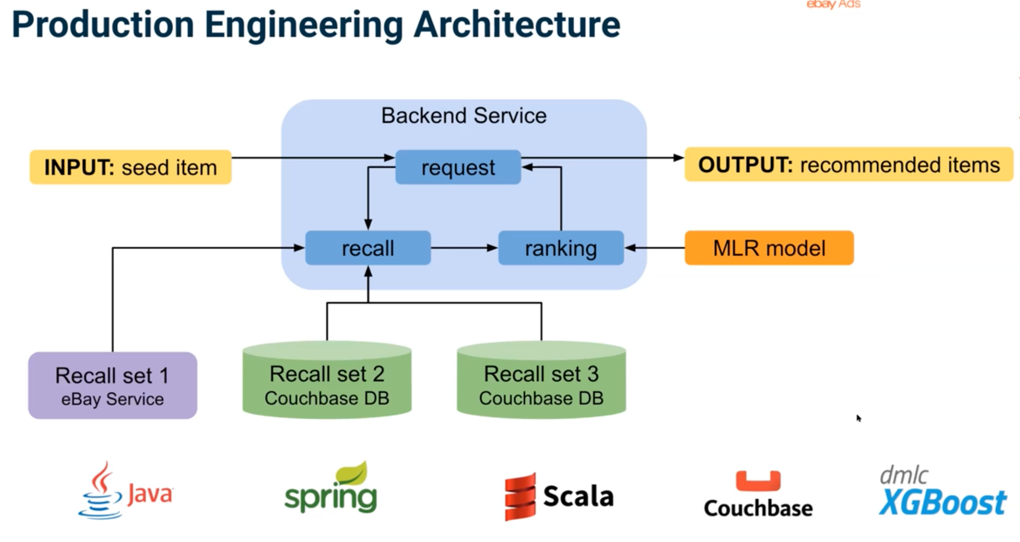

### Merch-Ads Algo Platform (MAP)

Platform to enable development of real-time item recommendations and page optimization for Merch placements at scale

Efficient development of new algorithms

Integrates with Cassini (Search), Krylov (Core AI) training model, BullsEye fo storing a lot of user features

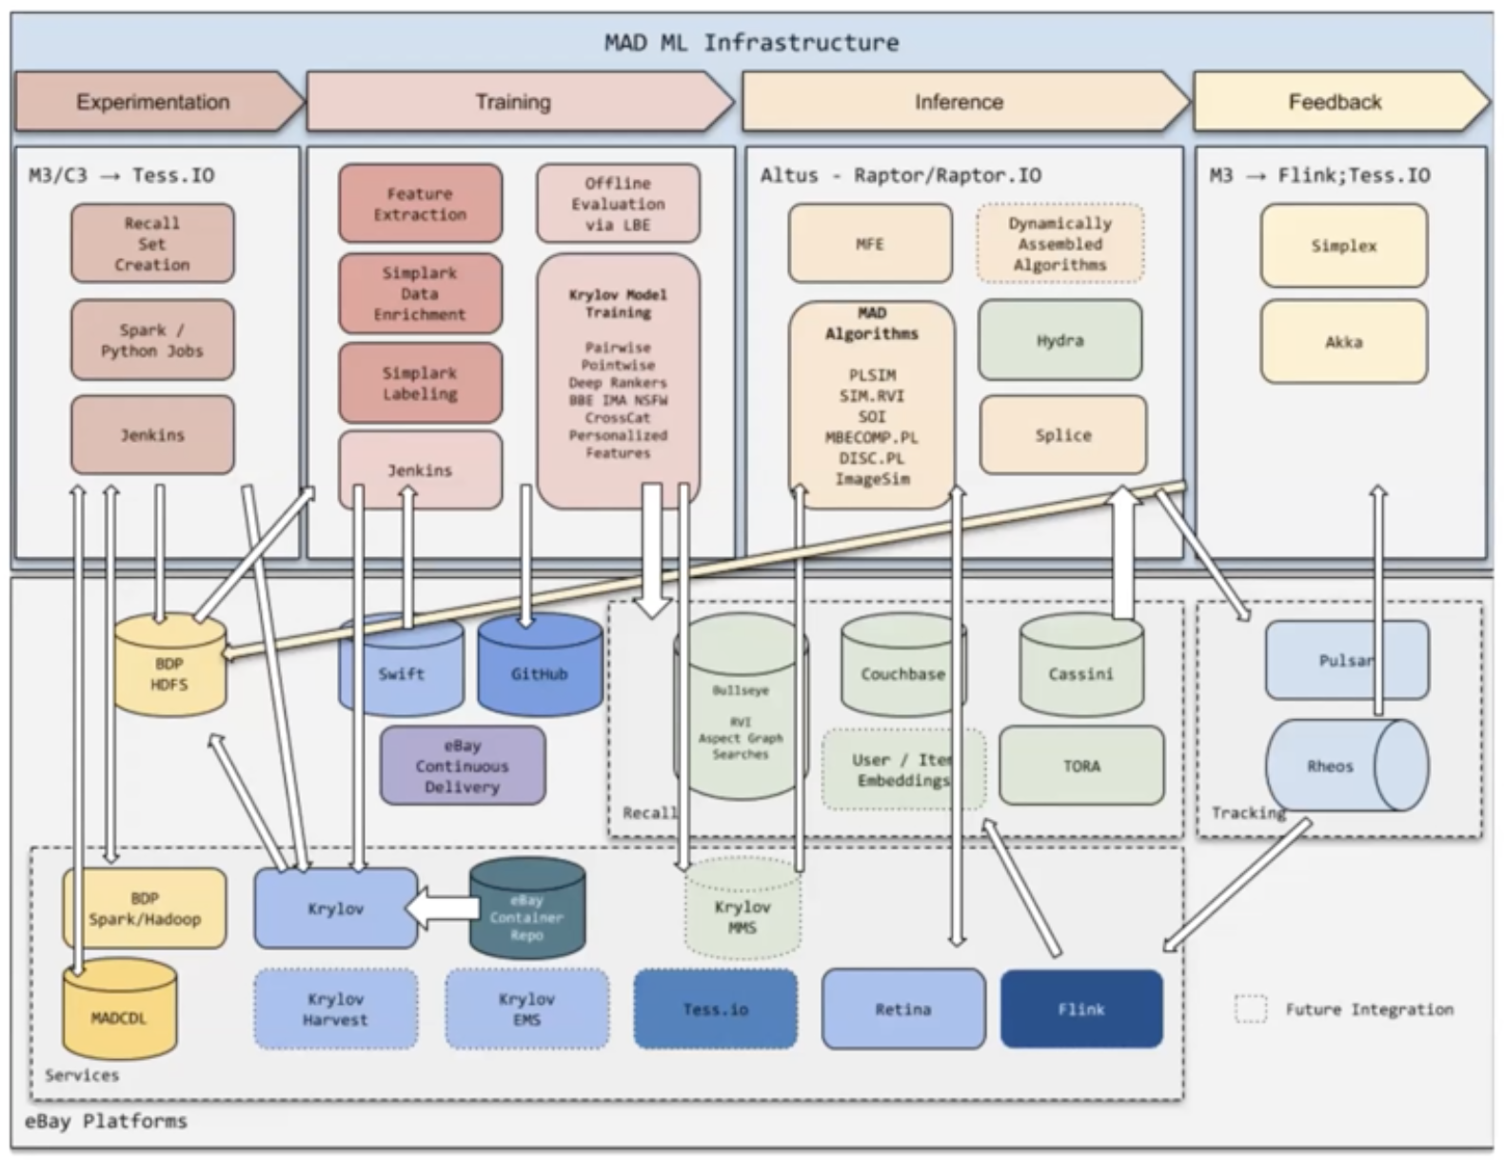

### MADS (Merch-Ads) Teams

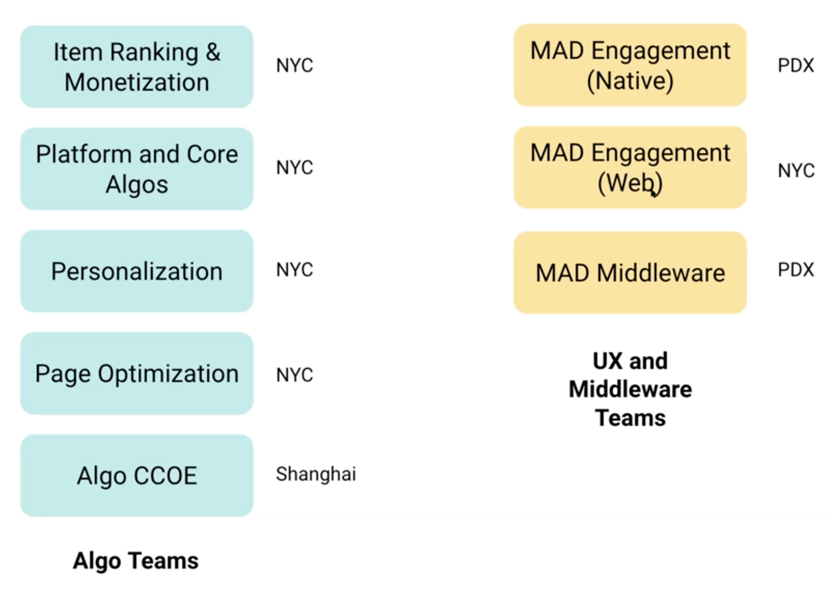

## Selling Interfaces

Places like Seller Hub, where sellers come and manage their items. Manage? Adding visibility, changing ad rates, and promoting items.

Manage their ads budget

Marketing tab to check performance

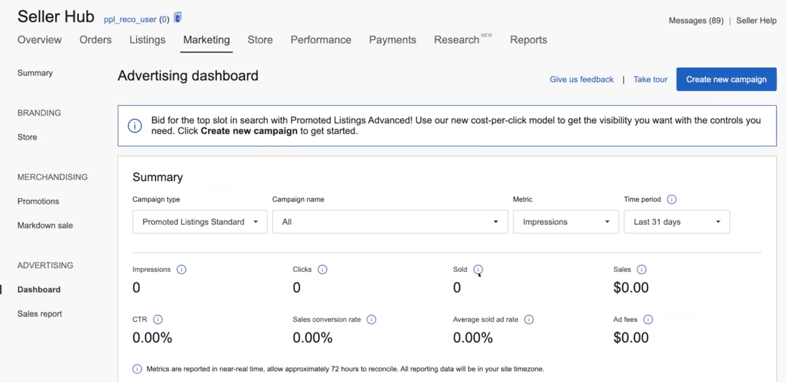

Can edit or create new campaigns (PLS, PLA, PLX)

PLS - pay per sale, PLA - per per click

PLS

* Simple
* Bulk (upload a file)
* Automated rule-based campaign

## Platform Core

Build common software foundation for advertising products

# Organic Realtime Ingest

Organic real time ingest pipeline built with Raptor.IO, Akka stream and Rheos.

It consumes several rheos topics for organic impressions and clicks. Currently it includes the following topics:

Page Id Description

2552134 SRP impressions

2317508 Merch impressions

2053444 Merch impressions

2388028 Merch impressions

2349624, 2047675 (under rheos topic VI) VI clicks

2356359 Native Organic clicks

2061037 Native Merch clicks

## Architecture

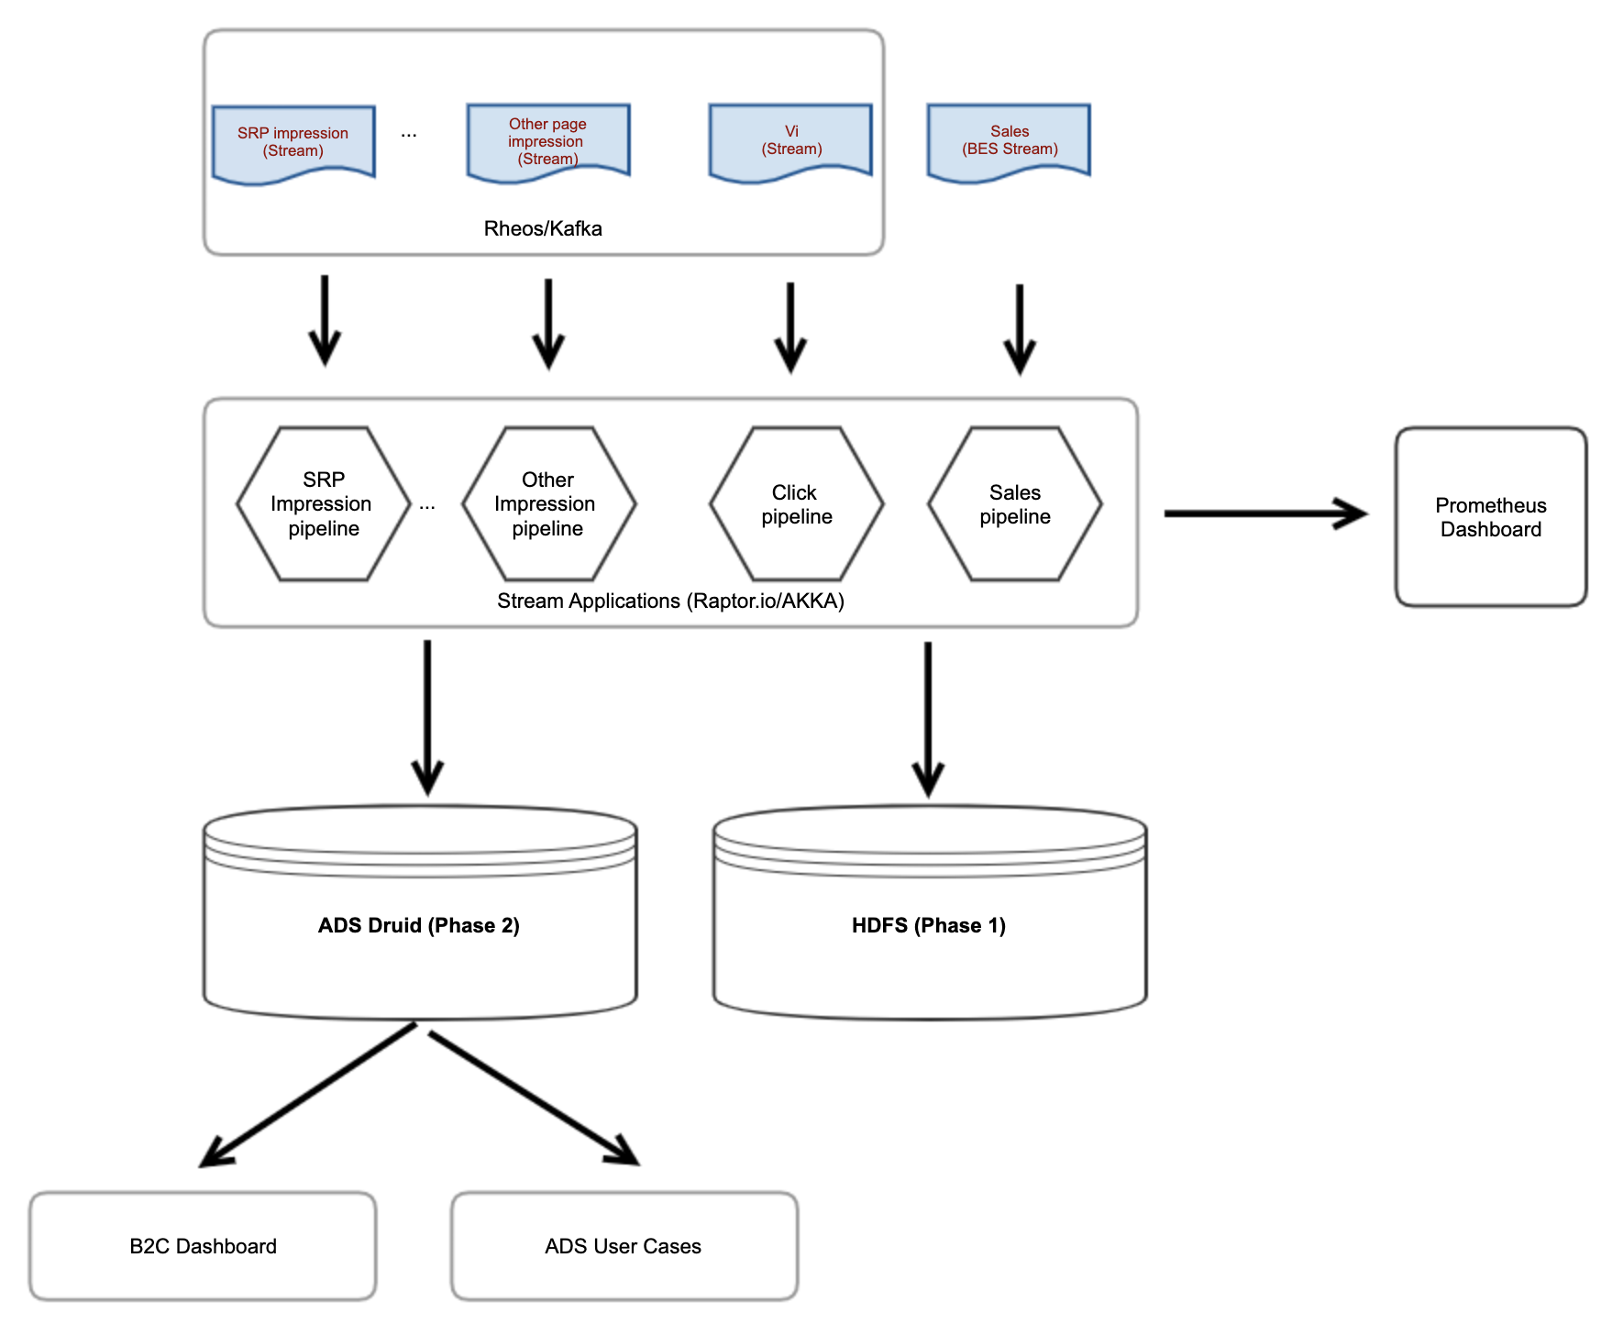

# People

## Organization Chart

Iannone, Jamie (President and CEO | Executive Admin)

|

Thompson, Pete (SVP, Chief Product Officer | Exec Leadership (SJC-INC))

|

Kazim, Alex (VP, GM, Global Advertising | Ads Exec (SF-NA))

|

Boff, Jean-Dominique (VP, Ads Product & Technology | Ads Exec (NL))

* Bligh, Josh (Sr. Product Manager 1 - Technical | Ads Product (SF-NA SN)
* Cheng, Julie (Heads of Ads, Engineering | Ads Exec (NYC-NA))
  + Kamperman, Jasper (Director, Software Development)
    - Joshi, Amit (Sr. Product Manager 1 - Technical)
    - Makhmutov, Timur (Software Quality Engineer)
* Danesh, Alyssa (Sr. Product Manager 2 - Technical | Ads Product (SF-NA - SN))
* Leelakrishnan, Vishnu (Sr. Product Manager 2 - Technical | Ads Product (SF-NA - SN))
* Lute, Jesse (Sr. Product Manager 2 - Technical | Ads Product (SF-NA - SN))
* Madhvanath, Sriganesh (Director, Data Science 2)
* Moye, Craig (Director: Global Ads Product Marketing | Ads Product (SF-NA - CM))
* Rosner, Ilana (Manager, Product Management 3 | Ads Product (SF-NA - SN))
* Tayal, Manish (Director, Product Management | Ads Product (SF-NA - MT))
* Uygur, Arman (Sr. Product Manager 2 - Technical | Ads Product (SF-NA - SN))
* Yanes Diez, Angela (Head of Product Operations and Culture | NYC-NA)
* Zhou, Weiyu (Director, Quality Engineer 2 | Ads QE (SJ-NA / WZ))

Madhvanath, Sriganesh (Director, Data Science 2)

* Friday, Angela (Manager, Software Development 3)
  + Deshazer, Lucas (Software Engineer 3)
  + Gaskins, Hannah (Software Engineer 2)
  + Hernandez, Elizabeth (Software Engineer 3, Quality)
  + Holmes, Rustin (Manager, Software Development)
  + Jones, Clyde (MTS 2, Software Engineer)
  + King, Robert (Software Engineer 3)
  + Kohler, Tracy (MTS 1, Software Engineer, Quality)
  + Lauter, Timothy (Software Engineer 3)
  + Mills Cannon, Ben (Software Engineer 3, Quality)

Holmes, Rustin (Manager, Software Development)

* Cruz Watla, Kevin (Software Engineer 1)
* Das, Angona (MTS 1, Software Engineer)
* Kandimalla, Shiva Reddy
* Li, Fengfu (Consultant)
* Rajula, Kavya Sree (Software Engineer 2)
* Simpson, Kevan (MTS 1, Software Engineer)
* Srinivasan, Padmapriya (Software Engineer 2)
* Wu, Jonathan (Consultant)

Zhou, Weiyu (Director, Quality Engineer 2)

* Iyamperumal, Ganesh (Manager, Quality Engineer 2 | Ads QE (SJ-NA / WZ))
  + Addanki, Srinivas (MTS 2, Software Engineer, Quality)
  + Balaswamy, Preeti (MTS 2, Software Engineer, Quality)
  + Dadhich, Saumy (Software Engineer 2, Quality)
  + Dondhe, Amith (Software Engineer 3, Quality)
  + Hanumanthu, Ashok (Consultant)
  + Jadon, Amit (Software Engineer 3, Quality)
  + Milli, Suma (MTS 2, Software Engineer, Quality)
  + Ravipati, Naveen (Software Engineer 2, Quality)
  + Singh, Uday (MTS 1, Software Engineer, Quality)
  + Suresh, Kavitha (Consultant)
  + Singh, Uday (MTS 1, Software Engineer, Quality)
  + Suresh, Kavitha (Consultant)
  + Tammisetti, Nandini
* Liu, Pavel (Manager, Software Development)
  + Chan, Jason (MTS 1, Software Engineer, Quality)
  + Ding, Tim (MTS 1, Software Engineer, Quality)
  + Huang, Yichao (MTS 1, Software Engineer, Quality)
  + Jason Bautista, Clark (Consultant)
  + Wang, Freecia (MTS 1, Software Engineer)
* Wang, Dawei (Manager, Quality Engineer 3)
  + Ding, Yang (MTS 1, Software Engineer, Quality)
  + Hairan, Wali (Software Engineer 1, Quality)
  + Jayakumar, Rashmi (MTS 2, Software Engineer, Quality)
  + Liu, Zhangyu (MTS 1, Software Engineer, Quality)
  + More, Prajakta (MTS 2, Software Engineer, Quality)
  + Patel, Vishal (Software Engineer 2, Quality)
  + Ren, Youchen (Software Engineer 3, Quality)
  + Sama, Vamshi (Software Engineer 2, Quality)
  + Tang, Grace (Software Engineer 2, Quality)
    - ​​Re: MFE Release
  + Thach, Peter (Software Engineer 1, Quality)
  + Veluvolu Venkata, Prade… (MTS 1, Software Engineer, Quality)
  + Xiao, Hancheng (Software Engineer 3, Quality)
  + Zhang, Xiaoyue (Software Engineer 3, Quality)
* Wang, Honghao (Sr. MTS, Software Engineer, Quality)
* Xie, Andy (Manager, Quality Engineer 3)
  + Ammorukindi, Venu
    - Re: PLRecoSvc - Test Report
  + Bian, Long (Software Engineer 2, Quality)
    - Re: ​​PLReports - Test Report
  + John, Preetha
  + Liu, Enze (Software Engineer 2)
  + Liu, Jiacheng (Software Engineer 2)
  + Madhu, Mythri (Software Engineer 3, Quality)
  + Mittapally, Aruna
    - Re: PLCPCSYNC - Release Report <https://wiki.vip.corp.ebay.com/display/PROMOTEDLISTINGS/Marketing+Dashboard+Experience+Service>
    - Re: PLCPCBES - Release Report

<https://wiki.vip.corp.ebay.com/display/PROMOTEDLISTINGS/Marketing+Dashboard+Experience+Service>

* + Nattamai Malli, Sankari (MTS 2, Software Engineer, Quality)
  + Puri, Meenakshi (Software Engineer 3, Quality)
  + Sapare, Shweta (Software Engineer 3, Quality)
  + Singh, Harwinder (MTS 1, Software Engineer, Quality)
  + Thenappan, Valli (Manager, Quality Engineer 2)
  + Villa, Venkat (MTS 2, Software Engineer, Quality)
  + Wei, Mike (MTS 2, Software Engineer, Quality)
* Yang, Laura (MTS 2, Software Engineer, Quality)
* Yu, Huiwen (Sr. MTS, Software Engineer, Quality)

Zhu, Yinxiao (Software Engineer 3 | DSS CNC)

Iannone, Jamie (President and CEO | Executive Admin)

|

Rawashdeh, Mazen (SVP, Chief Technology Officer)

|

Tian, Vivian (VP, GM, China Tech Ctr of Excellence)

|

Yang, Hua (Director, Software Development)

|

Zhou, Shawn (Director, Software Development 1 | Ads Engineering (CN - MS)) CCOE

* Liao, Jingyi (Intern)
* Lin, Yiying (Software Engineer 2)
* Liu, Fengxia (MTS 1, Software Engineer)
* Ping, Zixiu (Software Engineer 3)
* Ruan, Wenjun (Software Engineer 2)
* Shao, Bingcheng (MTS 1, Software Engineer)
* Shui, Han (Software Engineer 3)
* Sun, Keith (MTS 2, Software Engineer)
* Tang, Huayi (MTS 1, Software Engineer, Quality)
* Wang, Yixin (Software Engineer 2)
* Wu, Chaofan (MTS 1, Software Engineer, Quality)
* Wu, Marshall (Manager, Software Development)
* Yu, Chong (MTS 1, Software Engineer)
* Zhang, Yuqi (Software Engineer 2)
* Zhou, Chen (MTS 2, Software Engineer, Quality)

# Promoted Listings

## Performance dashboard

Your advertising dashboard gives you the metrics you need to analyze how your Promoted Listings Standard campaigns are performing. Metrics include:

* Impressions. The number of times your promoted listings have appeared on any eBay site.
* Clicks. The number of visits to a listing page from a promoted listing.
* Sold. The number of promoted items purchased within 30 days of a click on your promoted listings.
* Ad fees. The total amount of fees incurred by items sold within 30 days of a click on your promoted listings.
* Sales. The amount of sales generated by promoted items sold within 30 days of a click on your promoted listings.
* CTR. Click-through rate. Clicks divided by Impressions. The CTR is the percentage of times buyers saw your ad and clicked on it.
* Sales conversion rate. Sold divided by Clicks. The sales conversion rate is the percentage of promoted listings that are purchased after the buyer has clicked on them.
* Average sold ad rate. Ad fees divided by Sales. This number represents the average ad rate for items sold within 30 days of a click on your promoted listings.

Your campaign dashboard gives you a detailed listing-level view of how each campaign is performing. Features include:

* Trending values. See how your listing’s performance is doing over time.

## PL Overall Architecture

SELLER INTERACTS THROUGH LISTING PAGES AND CAMPAIGN MANAGEMENT DASHBOARD

BUYER INTERACTS THROUGH EBAY PAGES LIKE SEARCH, VIEWITEM, CHECKOUT, MYEBAY ETC

EBAY INTERACTS WITH REAL TIME ATTRIBUTION AND REPORTING PROCESS

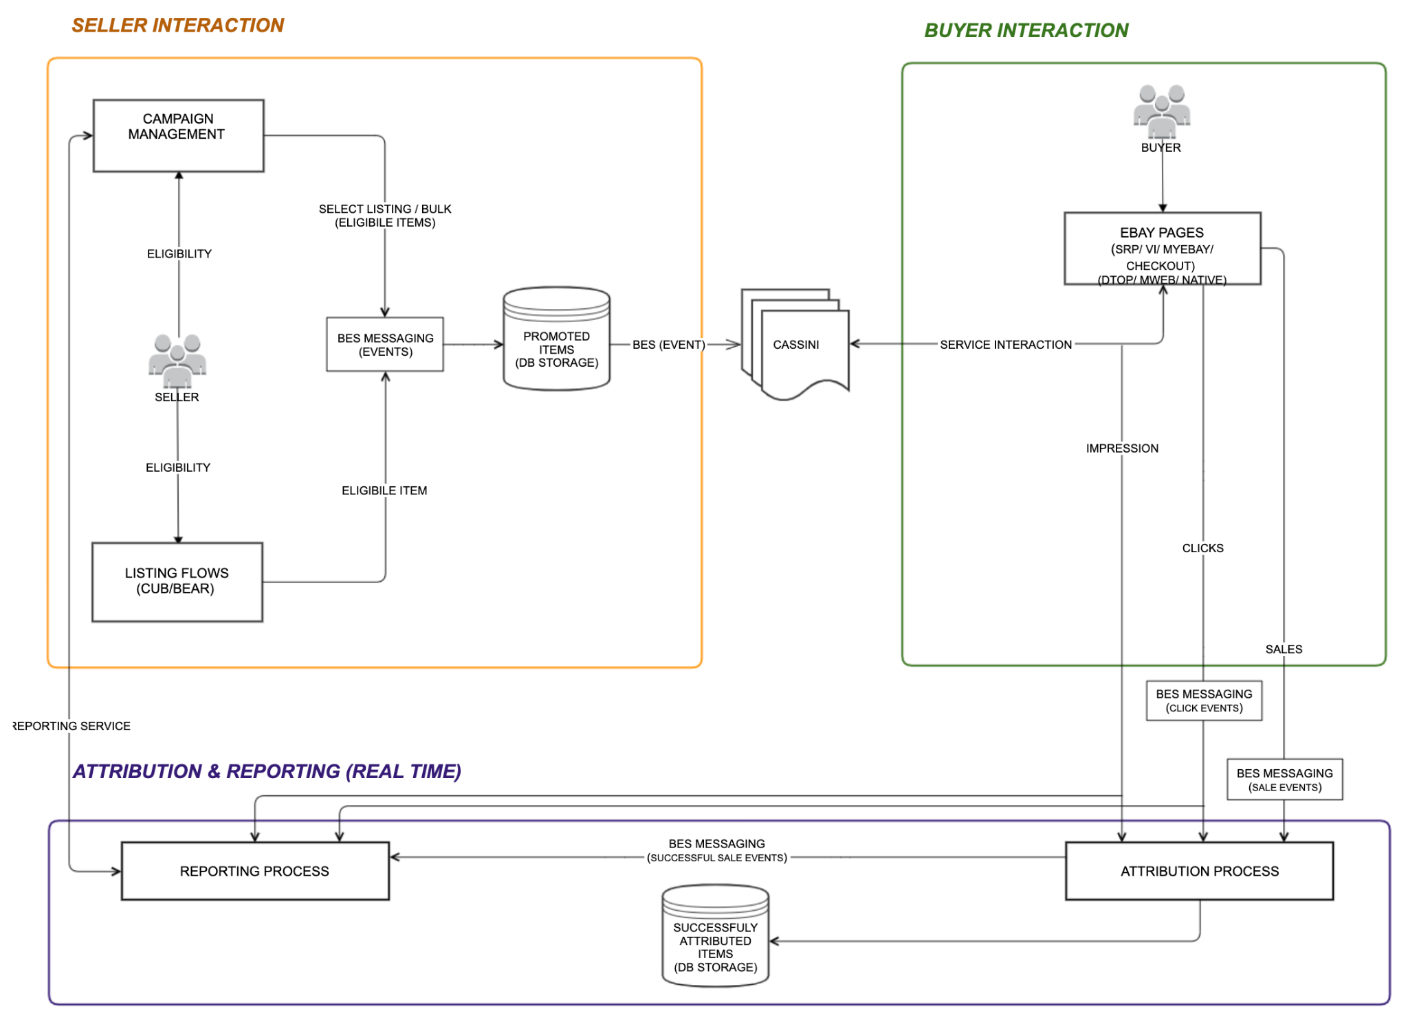

## Promoted Brand Architecture

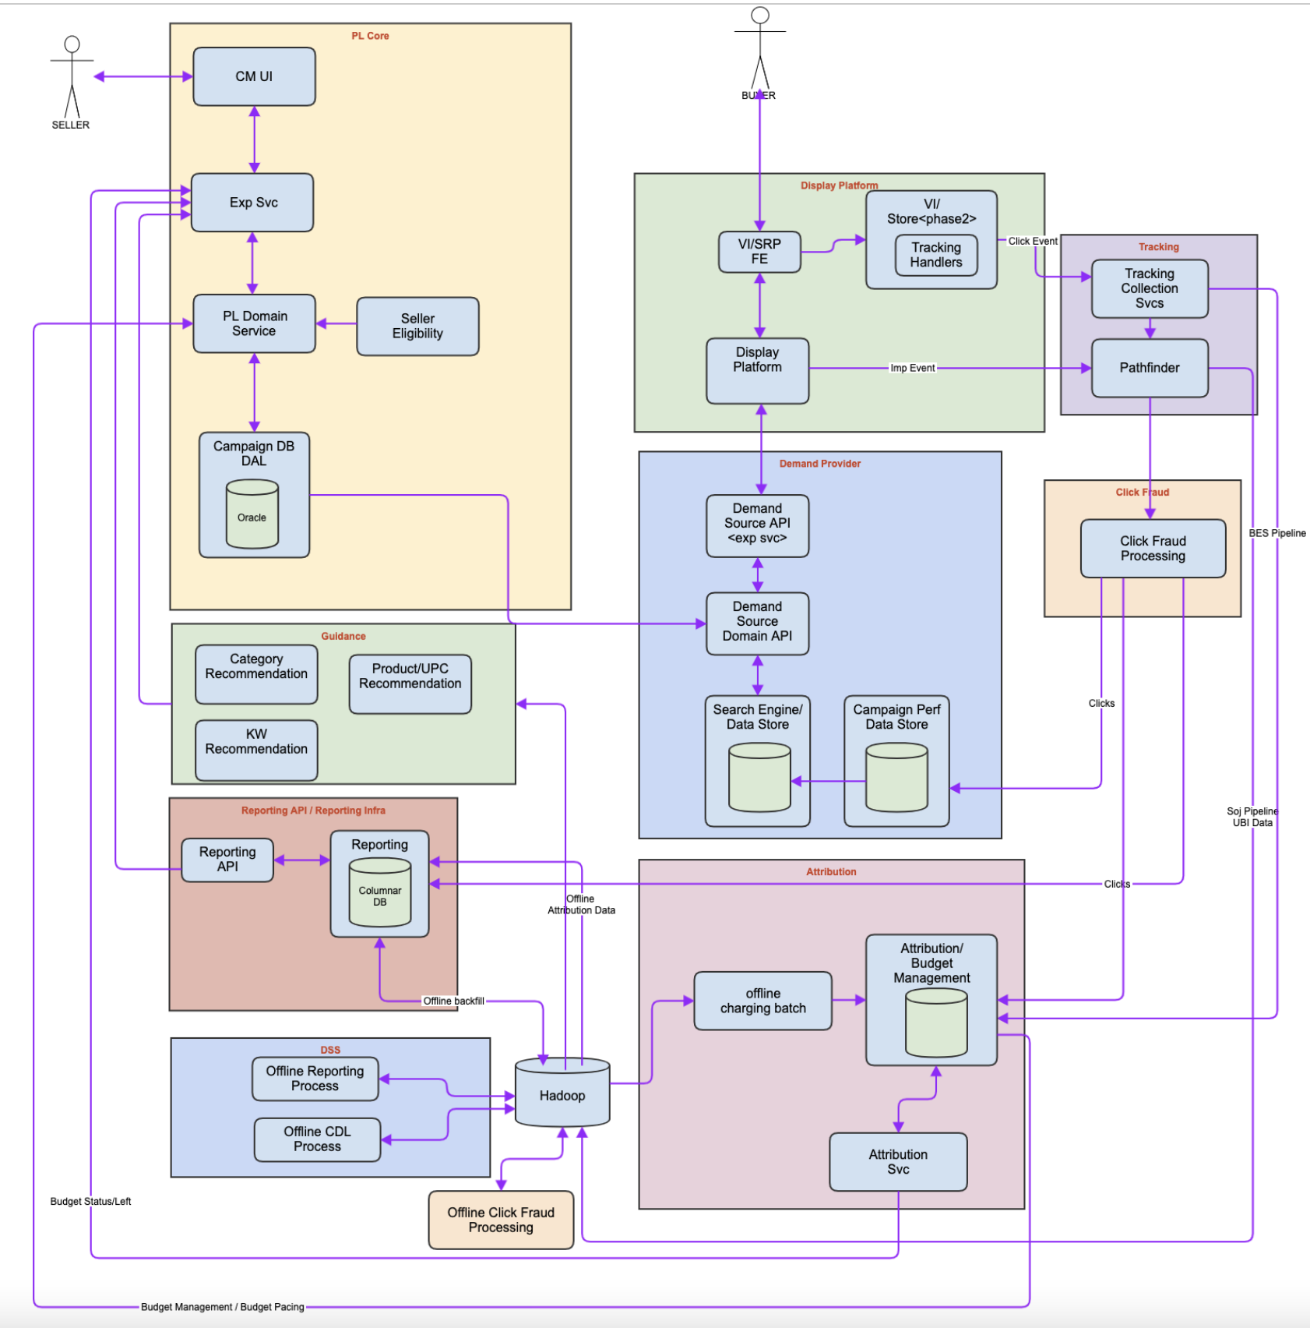

# Rheos

​​Rheos provides a fully managed, continuous scaling stream processing and messaging data platform, to power eBay’s vision of a near real-time buyer experience, seller insights, and a data-driven commerce business.

## NuMessage

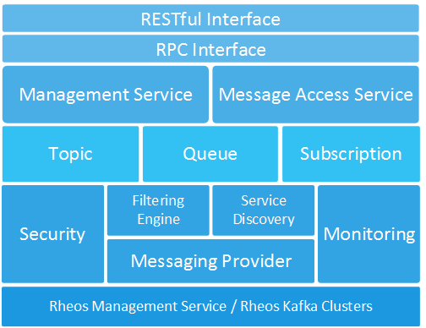

NuMessage provides a generic messaging platform which defines a group of standard messaging API and supports most of the messaging scenarios. Users could define their own messaging middle-ware and access it with light-weight client. NuMessage service hide all the implementation for users.

# Scenarios

# Search Page (SRP)

# Service Now

# Sherlock

## PromQL

# Sojourner

# Splice

## [Intro to Splice](https://hubtv.corp.ebay.com/video/141116.aspx)

What is splice?

Item features (Enrich items from cassini) -> MLR Model -> item scores (sort) -> response builder

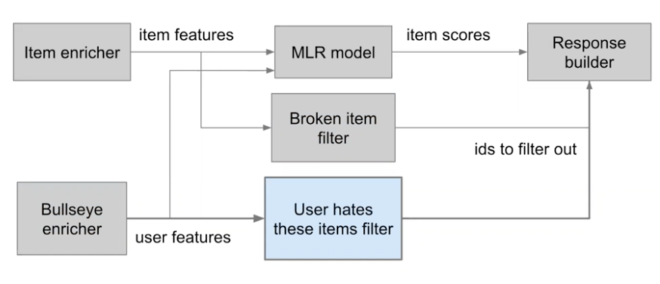

Before Splice

* Big handle function
* Lots of synchronization blocks
* timeBudget to not synchronized block a long time
* A lot of optional functions that are needed by some variants but not all.

In Splice

* Functions are stages

Code (scala)

* NullImageFilter extends Stage
  + override def label
  + override def requires - input
  + override def provides - output
  + override def run(input: DataMap): Task[DataMap] - similar to Future
  + provider.withConfigOverride
    - Not recommended to use. Can be slow. You’d get a huge performance hit
    - Entire config has to be parsed and re-extract from configuration objects
    - Mostly used for configuration testing in QA.
  + def canUse - optional inputs. It is okay if input is missing
  + requires vs canUse - during input data extraction, input.required will throw if key doesn’t exist, input.optional will not. Example: dataMap(“foo”) returns Int vs dataMap.get(“foo”) returns Option[Int]
  + How would the return builder know the type if DataMap can be a data type of anything? Ans. DataDependencyMapping - adds relationship to key type and value type
    - I.e.
      * val anyMap: Map[Any, Any] = Map(“foo” -> 42, 42 -> List(1,2,3))
      * val x: Any = anyMap(“foo”)
      * val xInt: Int = anyMap(“foo”).asInstanceOf[Int]
      * Might backfire with runtime casting issue: val xDouble: Double = anyMap(“foo”).asInstanceOf[Double]
      * No compiler error: val xString: String = anyMap(“foo”).asInstanceOf[String]
    - To add compiler error:
      * Map[Any, Any] // key: input / output data dependency, value: actual data points
      * case object ItemPrice extends DataDependency // key
      * Implicit val itemPriceEv = new DataDependencyMapping[ItemPrice.type, Double]
      * val dataMap: dataMap = DataMap(Map.empty)
      * val x = dataMap.required(ItemPrice)

pl / homesplice-config (repository)

Links

​​<https://github.corp.ebay.com/pl/splice>

<https://github.corp.ebay.com/pl/homesplice-config>

<https://github.corp.ebay.com/pl/splice/wiki/A-Simple-Splice-Example>

<https://sim.homesplice.pp.vip.ebay.com/api/v1/sim/dot/SimplAMLv5PairwiseWeb?rankdir=LR>  
<https://monix.io/docs/current/eval/task.html>

## Vanilla Space Overview

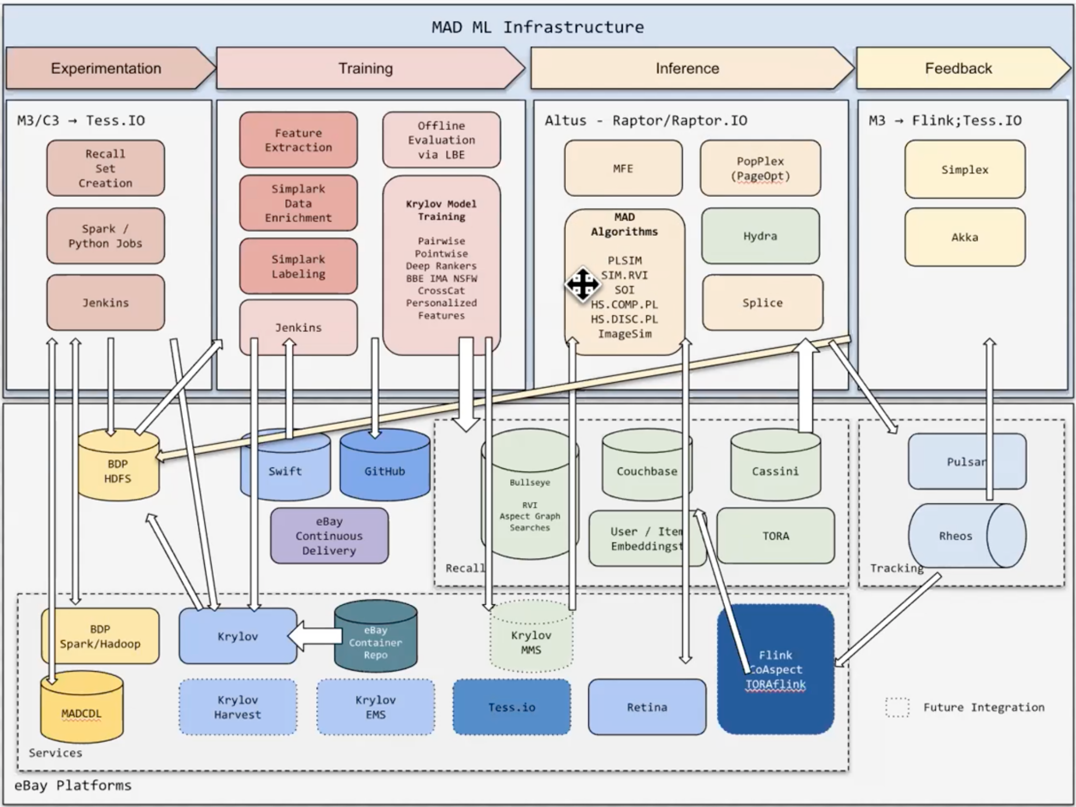

# Tabix

# VI (View Item) / VIP (View Item Page)

# Zeta

# 